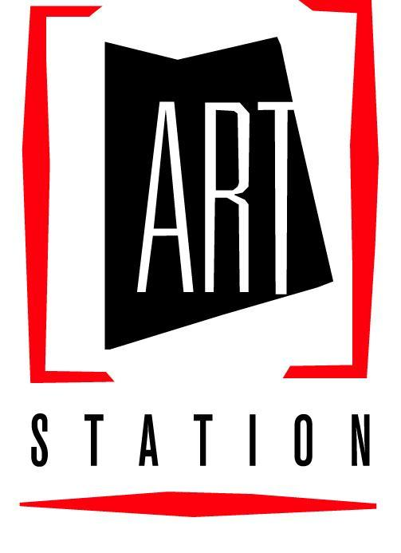
ART Station, Inc.
P.O. Box 1998
5384 Manor Drive
Stone Mountain, Georgia 30086
(770) 469-1105
artstation.org - info@artstation.org

ART STATION SILENT AUCTION FORM

Name of Donor:_______________________________________________________________________

Address:_____________________________________________________________________________

City:_________________________________________ State:_______________ Zip:________________

Email:______________________________________________________________________________

Description of Items or Services to be donated to ART Station:
______________________________________________________________

______________________________________________________________

______________________________________________________________

______________________________________________________________

Value of Donated Item(s):____________________________________________

(ART Station will provide you with a letter thanking you for your tax-deductible donation)

Please return this form to ART Station (P.O. Box 1998, Stone Mountain, GA 30086); located at 5384 Manor Drive in Stone Mountain Village (770) 469-1105.
All forms, donated items and/or services must be delivered or mailed
to ART Station no later than Sat., March 9th, 2023
(early submission is greatly appreciated).
Office hours are Tuesday through Friday 10 a.m.-5 p.m., Saturday 1-5 p.m.

Thanks very much for your support and we look forward to seeing you at
ART Station’s “Raising of the Green” fundraiser on Sunday, March 17th.

FOR OFFICE USE ONLY: Donation #: ____________

Opening Bid: _______________________ Increments of: ________________________

Solicited by: ____________________________________________________________

Date tax-deductible letter sent:__________________________ by:_______________

