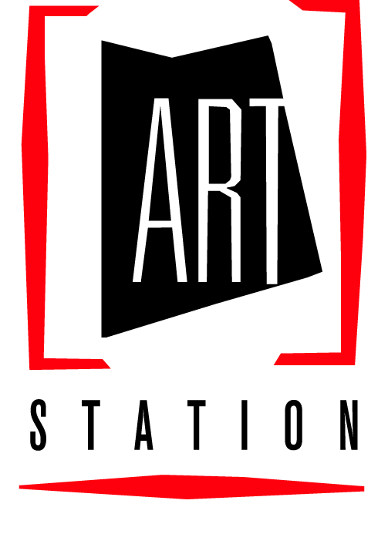

ART STATION SUMMER PROGRAMS 2018
Vital Information Form

CHILDREN ENROLLED IN ART STATION SUMMER PROGRAMS WILL NOT BE ALLOWED TO LEAVE ART STATION WITH ANYONE WHO IS NOT LISTED ON THIS PERMISSION FORM. NO PHONE CALLS WILL BE ACCEPTED TO CHANGE THIS FORM.
THERE ARE NO EXCEPTIONS TO THIS RULE!

Child’s Name: __________________________________________________Age: _________

Parents’ Names: _____________________________________________________________

Home Telephone Number: (_________) ___________________________

The following people may pick up my child/children from Youth Performance Company or Youth Arts Camp:

Name Relationship to child Phone Number

EMERGENCY NUMBERS
Mother at work (______) ________________________ Cell (_____)____________________
Father at work (______) ________________________ Cell (_____)____________________

Others to notify in case of an emergency:
___________________________________________________________________________
___________________________________________________________________________
___________________________________________________________________________

ADDITIONAL INFORMATION:
- Photos taken of your child in ART Station Summer Camp Activities and Performances may be used for publicity purposes.
- Checks dishonored by the bank will incur a fee of $25.00

__________________________________________ ________________
Parent / Legal Guardian Signature Date

(please see other side)

